1. SIMPLE LINUX COMMAND

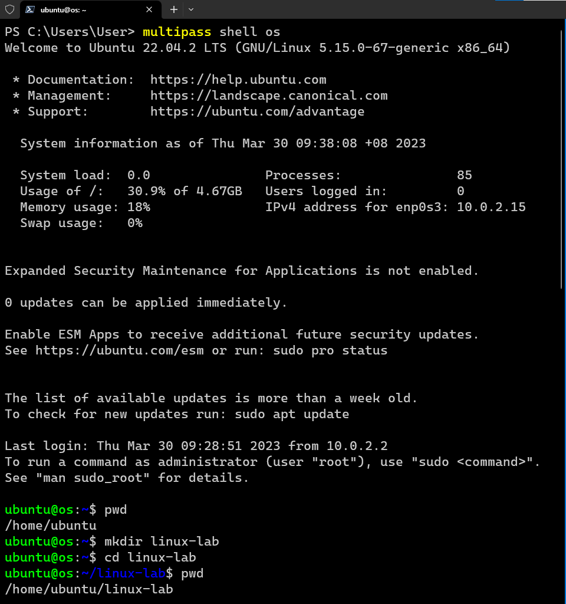

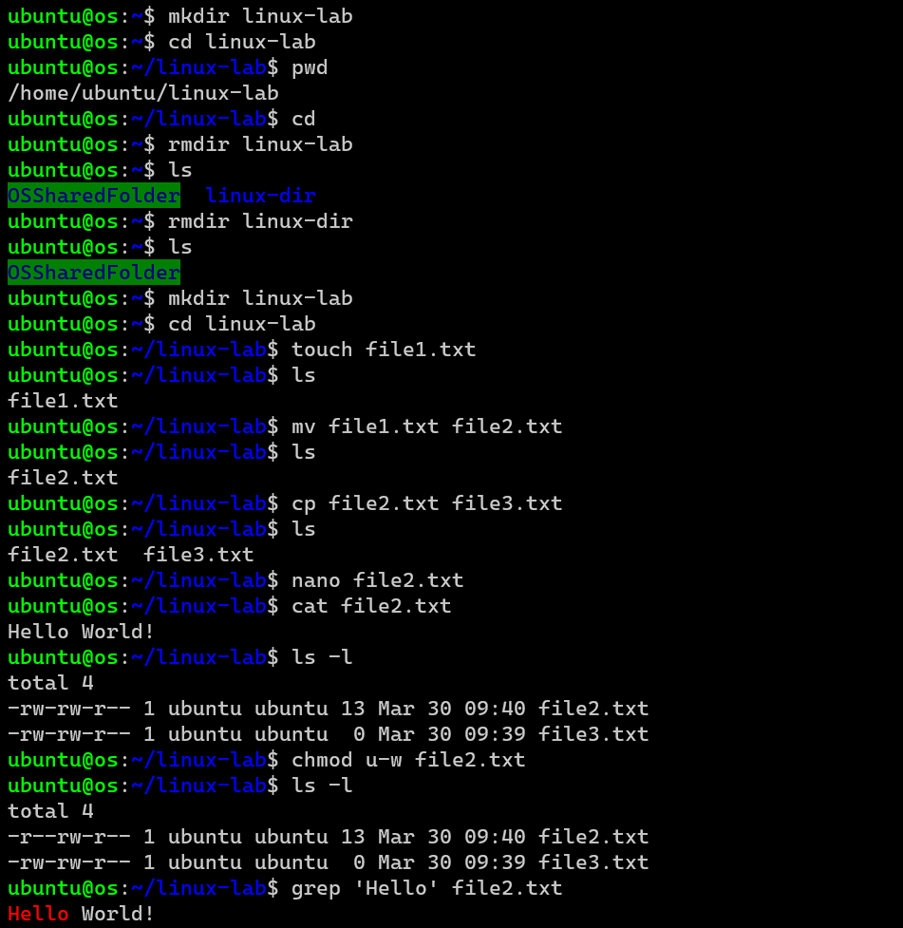

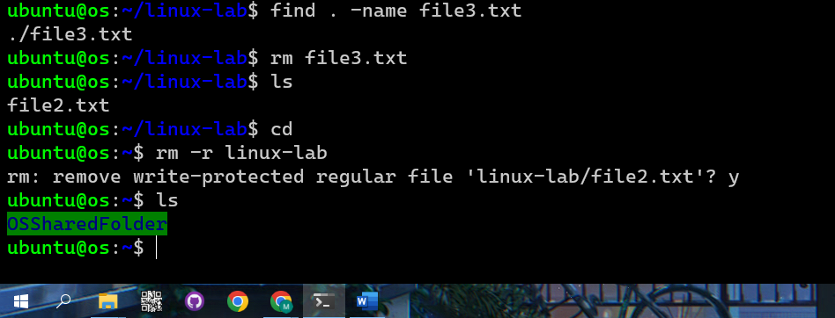

1. MANAGING PACKAGES/SOFTWARE IN UBUNTU

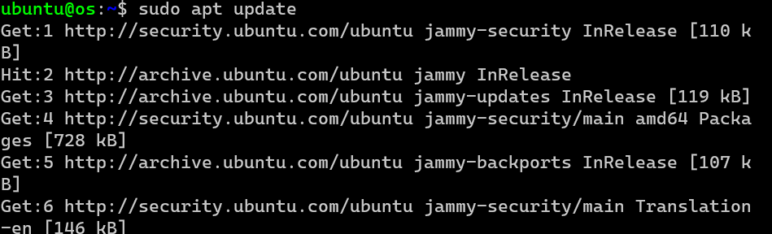

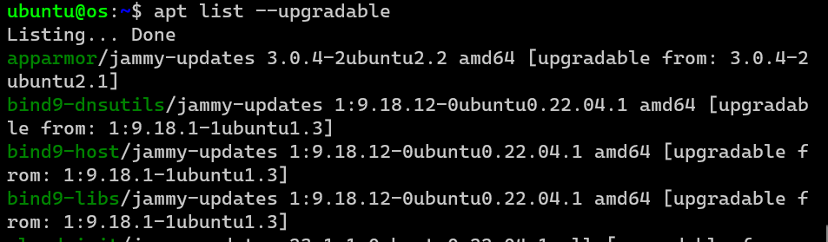

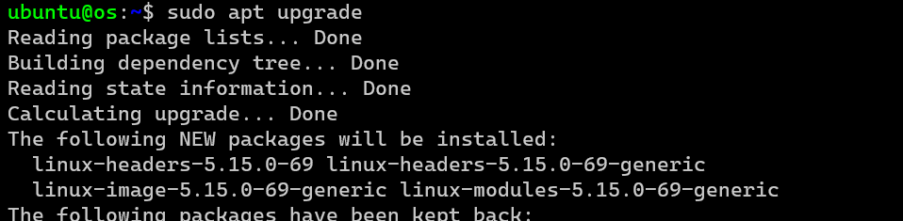

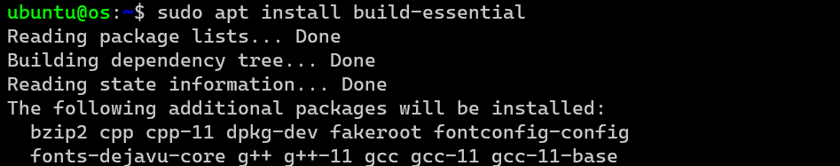

1. LAUNCHING NANO

